Writing 1 HOUR
TASK 01:
You should spend about 20 minutes on this task.
The graph below presents the employment patterns in the USA between 1930 and 2010. Summarise the information by selecting and report in the main features and make comparisons where relevant. Write at least 150 words.
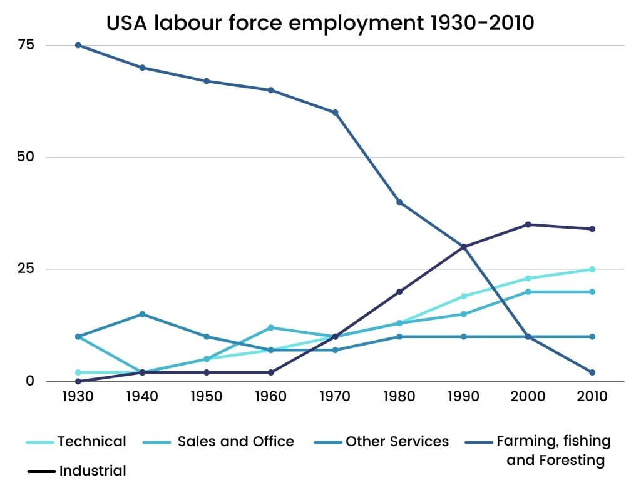

TASK 02:
You should spend about 40 minutes on this task.
With the rise of technology and automation, many people are concerned about the future of work and job security. What policies and practices can governments and businesses implement to ensure that workers are able to adapt and thrive in a rapidly changing economy?
Write at least 250 words.
Writing 1 HOUR
TASK 01:
You should spend about 20 minutes on this task.

You are preparing an event in the countryside.
Write a letter to your friend and ask for help with the arrangements.
In your letter,
- describe the event
- mention what arrangements have already been made
- say how your friend can help

Write at least 150 words.
You do NOT need to write any addresses.
Begin your letter as follows:
Dear ...................,

TASK 02:
You should spend about 40 minutes on this task.
With the rise of technology and automation, many people are concerned about the future of work and job security. What policies and practices can governments and businesses implement to ensure that workers are able to adapt and thrive in a rapidly changing economy?
Write at least 250 words.

